Using the 2G Soft SIM
by Chris Hessing

Installation

The 2G Soft SIM comes with the XSupplicant installation by default. During the installation you simply need to make sure the box is checked so that it is installed and configured properly. When you get to this screen :
Be sure that you have the option “2G Soft SIM” checked. This will cause the Soft SIM and all related tools to be installed.

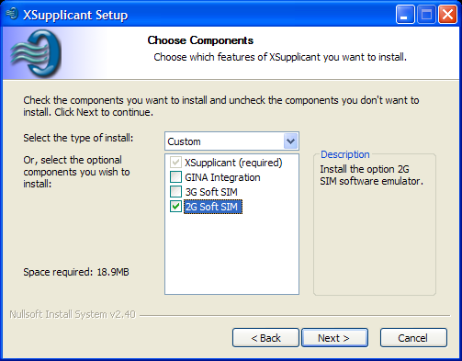
Be sure that you have the option “2G Soft SIM” checked. This will cause the Soft SIM and all related tools to be installed.

Configuring the Soft SIM

The configuration for the 2G Soft SIM is a matter of installing a triplet file in the proper location. The file should be called 2Gsim.txt, and installed in \Documents and Settings\All Users\Application Data. (Application Data is a hidden directory so it won't show up in explorer or from the command line using a “dir”.)

The format of the file is IMSI:KC:SRES:RAND, with any line starting with a “#” considered to be a comment.

A sample of the 2Gsim.txt file is below :

# SIM triplets file generated by SIM Tool.
#
# This file is formatted to be used with the Radiator RADIUS server, or the # XSupplicant 2G SoftSIM.
#
# Format is :
# IMSI:KC:SRES:RAND
001010123456789:B27114F4B23C0429:04E3BE39:2923BE84E16CD6AE529049F1F1BBE9EB
001010123456789:63618D56C53712ED:9FB7585C:B3A6DB3C870C3E99245E0D1C06B747DE
001010123456789:B64E8EC659256C09:986FA401:B3124DC843BB8BA61F035A7D0938251F
001010123456789:AAA235E9306EE081:F57FFA40:5DD4CBFC96F5453B130D890A1CDBAE32
001010123456789:42D1D6089DA93DC1:EE3B34E6:209A50EE407836FD124932F69E7D49DC
001010123456789:C0AAD37AB435CBDC:55154FA0:AD4F14F2444066D06BC430B7323BA122
001010123456789:0294C1602961F7DC:058324D5:F622919DE18B1FDAB0CA9902B9729D49
001010123456789:7089C7FDA34DCE1A:FFA81EA8:2C807EC599D5E980B2EAC9CC53BF67D6
001010123456789:4F07D266AF5773E9:048075F7:BF14D67E2DDC8E6683EF574961FF698F
001010123456789:0CDE698A490B60A8:7397FE97:61CDD11E9D9C167272E61DF0844F4A77

Configuring the Supplicant to use the Soft SIM

Configuring the supplicant to use the soft SIM is fairly simple. The Soft SIM presents itself to the supplicant as another SIM card reader, so the process used to configure a normal SIM connection is the same if you are using the soft SIM. Open the configuration window by double clicking on the tray icon, selecting the “Tools” option, and then “Configure..”

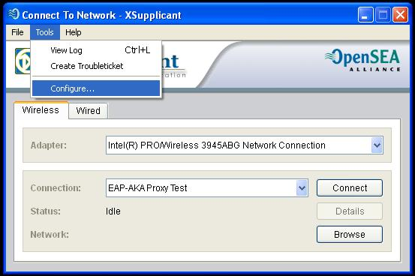
This will cause the configuration window to open :

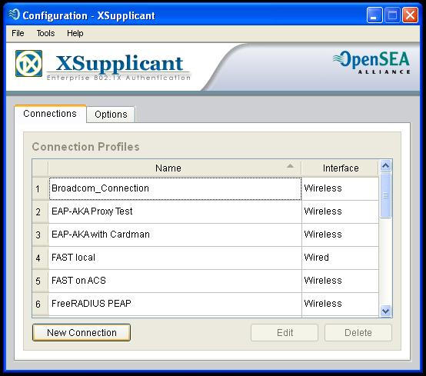
Click on the “New Connection” button to create a new SIM connection. This will bring up the first window in the configuration wizard.

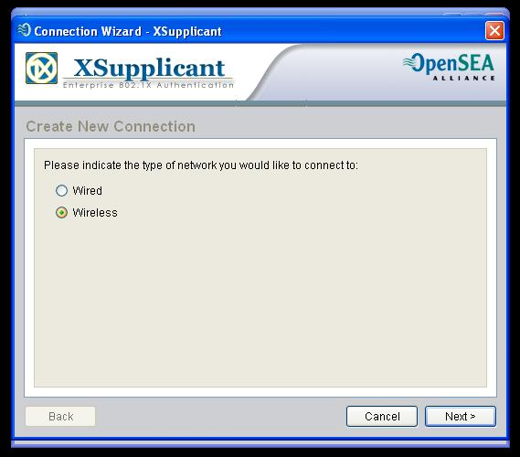
Select the type of connection you are going to use, and click “Next” to bring up the second window in the wizard.

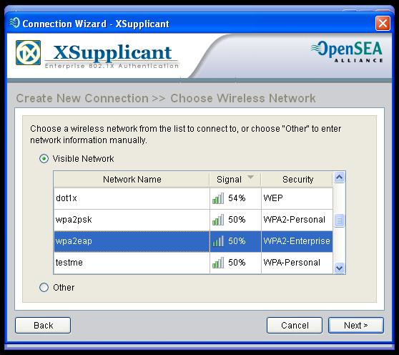
If you are using wireless, select the wireless network that you will use SIM authentication with, and click “Next” to go to the next window in the wizard. (If you are using wired, skip this step.)

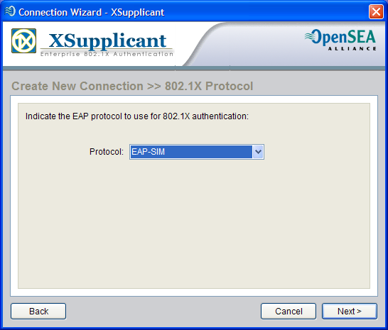
In the Protocol drop-down box, select “EAP-SIM”, then click “Next” to move on to the next window in the wizard.

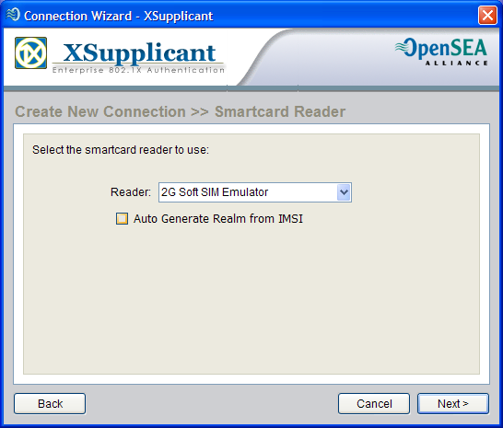
For the smart card reader, select “2G Soft SIM Emulator” to use the emulated smart card you created earlier. If you need to auto generate the realm, you can check the box for that here as well. Once you have done this, click “Next”.

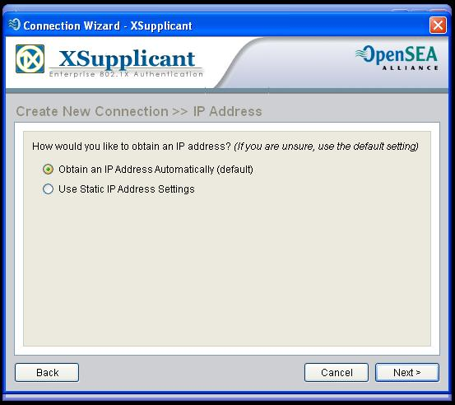
If you are using DHCP, select “Obtain an IP address automatically” here. Then click “Next”.

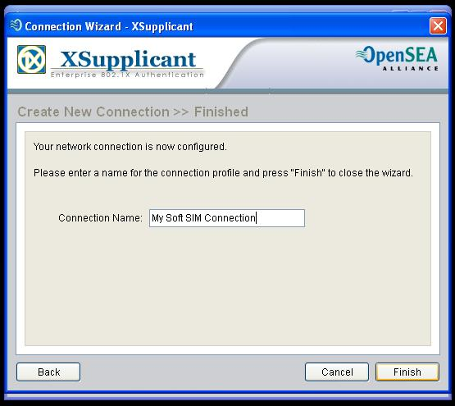
Finally, give your connection a meaningful name, and click Finish.

Using the newly created Connection

Using the connection you just created is done the same way that you would use any other connection. Double click on the tray icon, select the wired or wireless interface you bound this connection to, select the connection from the drop-down box, and click connect. You may be prompted for a PIN. If you are, enter any 4 to 8 numeric digits. Finally, when you click connect, you should go to “Connected” state without any other dialogs as long as you have configured your AP and RADIUS server correctly.

